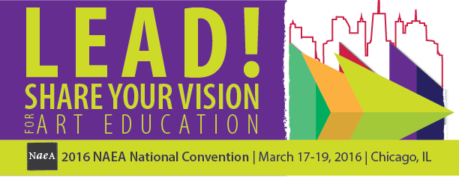

Chicago Special Events National Art Education Association
March 17-19, 2016
Chicago, IL

Thursday, March 17

11:00 am – 12:50 pm
Chip Art - Frisky & Free Paper Mosaics (Hands-on Workshop)
Elementary, Middle, Secondary
Groundbreaking new art medium! Harnessing tons of obsolete paint chips previously destined for landfills. Simple, impactful lesson repurposing chips into beautiful art. Hands-on, unique design project delivers meaningful results for all ability levels. Fresh Artists gives free CHIP ART kits to schools in need via a national partnership with BEHR Paint.
Fresh Artists Founder Barbara Chandler Allen & Program Manager Desiree Bender

Ticket Price: $39 Maximum Number of Participants: 75

7:00 – 10:00 pm
Opening Night Event
Collaborate with art educators from around the globe to kick off the Convention by celebrating art education in the Windy City! Get your green on! It will be St. Patrick’s Day in the Windy City! Music, prizes, the NAEA Artisans Gallery, and more will be part of this epic event!

Ticket Price: $10
{Tickets are available only to registered attendees and their registered guest}

