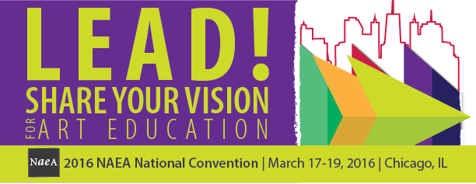

Meals
National Art Education Association
March 17-19, 2016
Chicago, IL

Friday, March 18

12:00 – 1:50 pm

USSEA Luncheon Edwin Ziegfeld Award and Luncheon
The USSEA Edwin Ziegfeld Award and luncheon celebrates international and national scholarship and national service. Join this celebration award with your colleagues and applaud their outstanding achievements.
Menu:

Sui Chou Salad containing Fresh Soya Beans, Mung Bean Sprout, Wonton Crisp
and Young Ginger Asian Plum Dressing; Lemon and Garlic Roasted Breast of Chicken Served with Rosemary Roasted Seasonal Vegetables and Creamy Herbed Polenta; flourless chocolate cake; served with assorted rolls and butter, freshly brewed regular and decaffeinated coffee, hot tea, and iced tea.
Ticket Price: $50

Price includes 21.50% service charge, 10.25% sales tax, and other applicable IL taxes.

