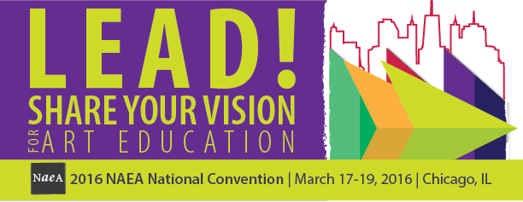

Exhibitor Showcase Workshops
Chicago Hilton Hotel
Friday, March 18, 2016

Exhibitor Showcase Workshops presented by NAEA Exhibitors are back!

These workshops are open to all NAEA Convention registrants. There is no charge for these workshops; however, a ticket must be reserved through the online NAEA Registration system. Workshops are limited to 150 participants. Please do not sign up for a ticket unless you really plan on attending. You may only sign up for one workshop.

5:00 – 6:50 pm
Copic Marker by Imagination International
Modern Rendering Techniques Using Copic Markers
This hands-on workshop introduces you to blending, textures, and effects created with Copic refillable markers. Free lesson plans for 6th- 12th-grade teachers. Receive marker sampler packs and information on professional rendering techniques to prepare your students for college and commercial art careers.

5:00 – 6:50 pm
Tombow
Tombow Tangles With Color!
A Certified Zentangle Teacher will demonstrate the popular method of creating beautiful images with repetitive patterns, offering students increased focus and creativity. All ages and skill levels enjoy this intuitive art form. The tangled “flapper fan” project will be loads of fun and a perfect classroom project! Come and learn new patterns and then combine them with wondrous color using Tombow’s Dual Brush Pens using a variety of fun methods. A relaxing and informative workshop that produces a beautiful piece of artwork created by you!

5:00 – 6:50 pm
Columbus College of Art and Design
The Tide is High But I’m Holding On
The Columbus College of Art & Design (CCAD) is responding to shifting tides in higher education by developing tools and approaches like Transformative Project-Based Learning (TPBL), innovative course integration, and immediate immersion in the major. Using case studies around TPBL, strategies around immersion and integration, and the desires of Generation Z as a backdrop, this workshop will provide participants with tools to construct relevant curricula that will prepare their students for productive engagement in a creative education. Presented by Professor Tom Gattis, Dean School of Design Arts, and Associate Professor Tam Peterson, Associate Director CORE Studio.

5:00 – 6:50 pm
Blick Art Materials
Figures in Motion
Looking for an inexpensive way to create figure sculpture? In this Blick Art Materials workshop, make an accurately proportioned paper-doll-type cardboard figure that can be manipulated while wet into a pose that expresses movement. Once dry, the sturdy figure can be painted and decorated as a mixed-media piece.

